Customer Shopping Behavior Analysis

Project Overview
This project analyzes customer shopping behavior using transactional data from 3,900 purchases across various product categories. The goal is to uncover insights into spending patterns, customer segments, product preferences, and subscription behavior to guide strategic business decisions.

Dataset Summary
- Rows: 3,900
  - Columns: 18
  - Key Features:
    - Customer demographics (Age, Gender, Location, Subscription Status)
    - Purchase details (Item Purchased, Category, Purchase Amount, Season, Size, Color)
    - Shopping behavior (Discount Applied, Promo Code Used, Previous Purchases, Frequency of Purchases, Review Rating, Shipping Type)
  - Missing Data: 37 values in Review Rating column

Exploratory Data Analysis using Python
We began with data preparation and cleaning in Python:

- Data Loading: Imported the dataset using pandas.

- Initial Exploration: Used df.info() to check structure and .describe() for summary statistics.
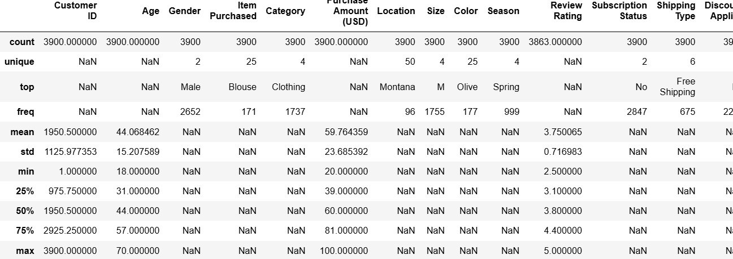

Dashboard in Power BI

Finally, we built an interactive dashboard in Power BI to present insights visually.
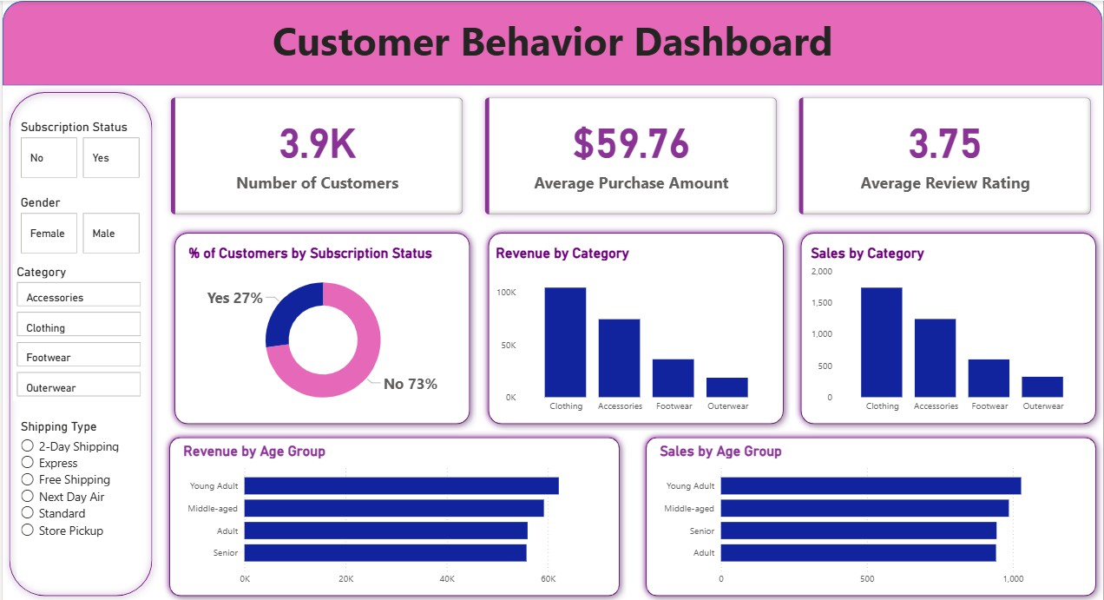

- Business Recommendations

- Boost Subscriptions – Promote exclusive benefits for subscribers.
- Customer Loyalty Programs – Reward repeat buyers to move them into the “Loyal” segment.

- Review Discount Policy – Balance sales boosts with margin control.

- Product Positioning – Highlight top-rated and best-selling products in campaigns.

- Targeted Marketing – Focus efforts on high-revenue age groups and express-shipping users.

